# **Language Detection Web Application – Duck Soft Works § Co.**

**US 3 -**  **As a user, I want to obtain information about the tasks in progress and already completed, by category and/or status.**

## **1. Requirements Engineering**

### **1.1. Customer Specifications and Clarifications**

N/A - No questions have been asked in order to further clarify requirements for this US.

### **1.2 Customer Specifications and Clarifications**

**From the specifications document:**

The system should implement functionalities that allow users to retrieve information for tasks by state of completion , category or both.

### **1.3. Acceptance Criteria\***

If no tasks have been submitted at all, no results should be found.

Tasks retrieved in the search must only be those submitted by the user.

No tasks should be retrieved , when searching by category , if no task was previously submitted with said category.

When filtering by state of completion, no tasks besides the ones with the specified state of completion should be shown.

### **1.4. Found out Dependencies**

Dependency with US1, since task creation must exist prior to task search being possible

### **1.5 Input and Output Data\***

To find a task by category , a valid category name must be provided.

To find a task by status of completion , a valid status must be provided.

Output data will always be based on the kind of filters applied in the request , returning an appropriate response.

### **1.6. System Sequence Diagram (SSD)\***

Note:

Please refer to the indexed generic findall SSD as it illustrates the behaviour for this US.

## **2. OO Analysis**

### **2.1. Relevant Domain Model Excerpt**

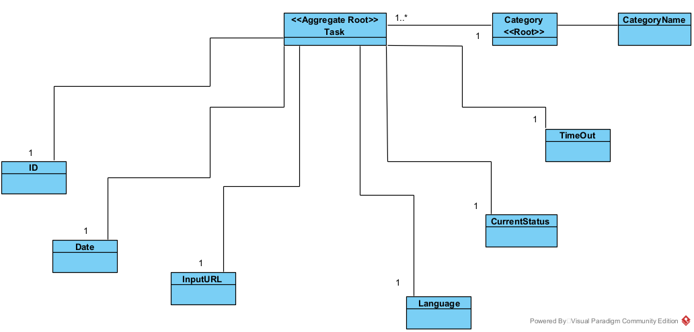

## **3 Sequence Diagram (SD)\***

Please refer to the indexed generic findall SD as it illustrates the behavior for this US.

## **3.1 Class Diagram (CD)\***

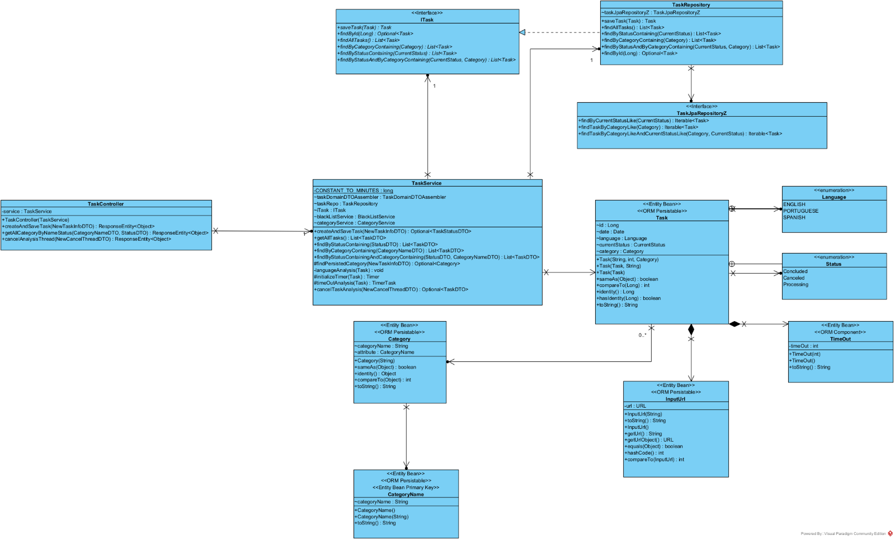

# **4. Construction (Implementation)**

Implementation was based on the basis that searching a task could be both by category or state. We also provided methods that allow searching for both .

Even though there isn’t a specific requirement to find all tasks, regardless of criteria for either category or state, this functionality was implemented as we considered that it could prove itself to be useful in terms of scalability.

# **5. Integration and Demo**

As far as integration goes, any request that specifies finding tasks by **category** or **status**(or both), requires these search parameters to be valid, i.e., to already be present in the system.

# **6. Observations**

Testing the methods for these specific functionalities were difficult.

Despite the application being stable and functional, the tests for the case were a specific task is searched by supplying a specific category and by supplying both category and state were not passing. It might be because of either reengineering the application several times or the test themselves not being designed properly. Nonetheless, these tests remain inconclusive and, despite all efforts, could not be carried out successfully.

For the time being, as the user system is yet to be implemented, these searches cannot be user specific, thus any request will show all available tasks, regardless of which user created that task in the first place. It is something to be improved in the next iteration of the project.